How to install the easy 68000 to edit, assemble, and run 68000 programs.
- Go to this site: http://www.easy68k.com/

- At the end of the home page go to Download and chose SetupEASy68K.exe and download it.
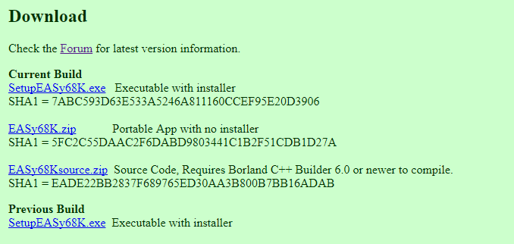

When you open the EASy68K editor/assembler (EDIT68K.exe) you will see a screen like this:

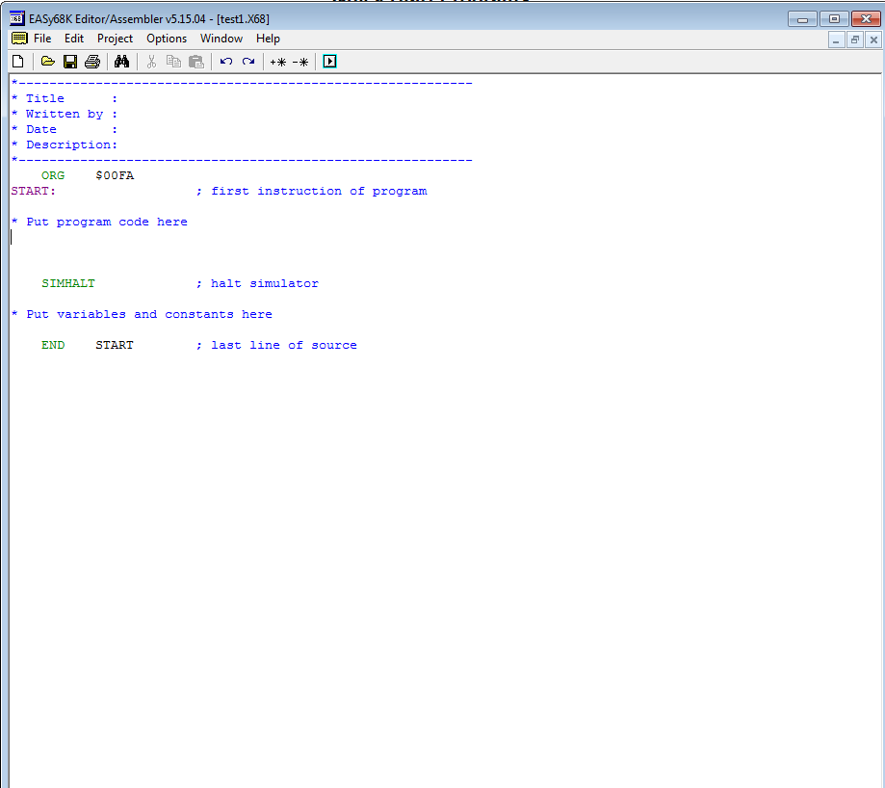

Copy and Paste this code her
sub d0,d0
move d0,a0
movea a0,a1
move X(a0),d1
move inc1(a0),d2
move ten(a0),d3
while add d2,d0
cmp d0,d3
bgt DO
bra DONE
DO adda d2,a1
adda d2,a1
move X(a1),d3
cmp d1,d3
beq while
blt while
move d3,d1
bra while
DONE move d1,L(a0)
move three(a0),d0
trap #0
X dc 5,6,10,15,3,7,9,6,11,15
ten dc 10
inc1 dc 1
three dc 3
L ds 1

- This code is to find the largest value in array and the final answer is 15
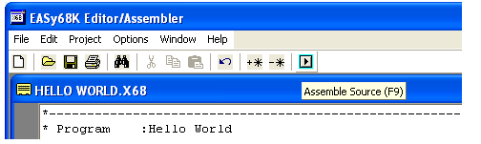
- Now we will assemble and run our program, first click the assemble button, which looks like this.

- Once the program is assembled without error click the execute button, which will open the EASy68K simulator like this.

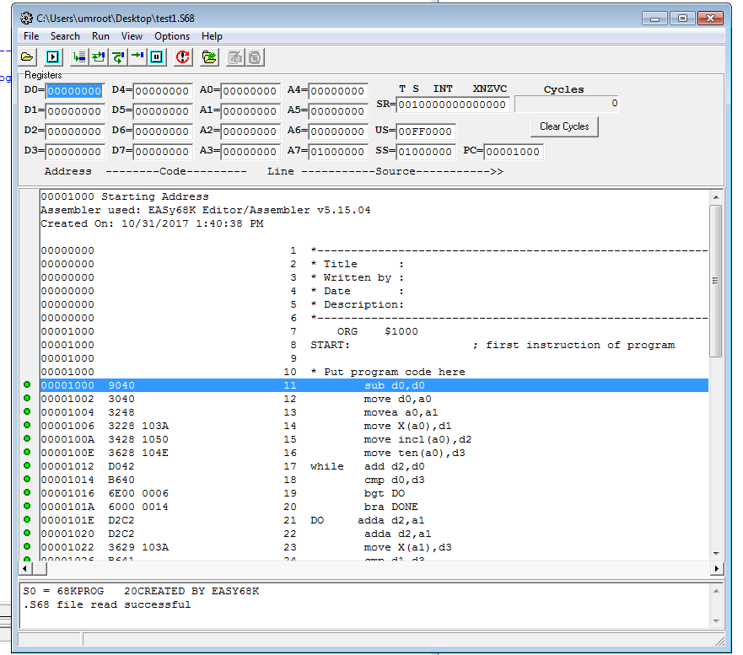

- Next to start the program you will press the run button, which resembles the assemble button

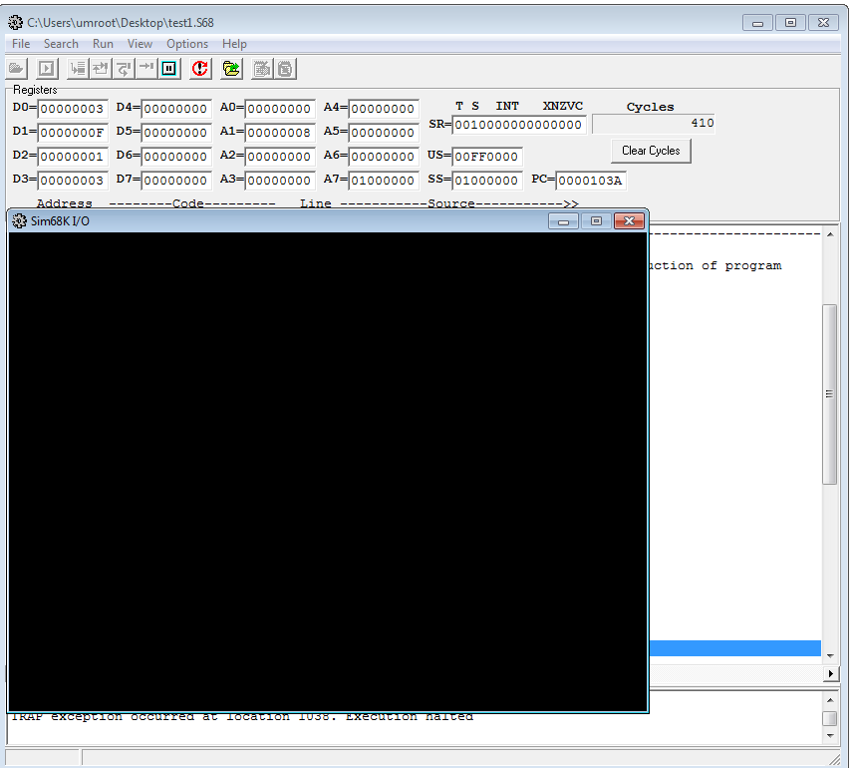

You can see that the value of register D1 = F = 15 which it the largest value because we always store the largest value in D1 then we store it in the memory “move d1,L(a0)” . To check the values in the memory go to view

Then chose memory which will open the memory like this.
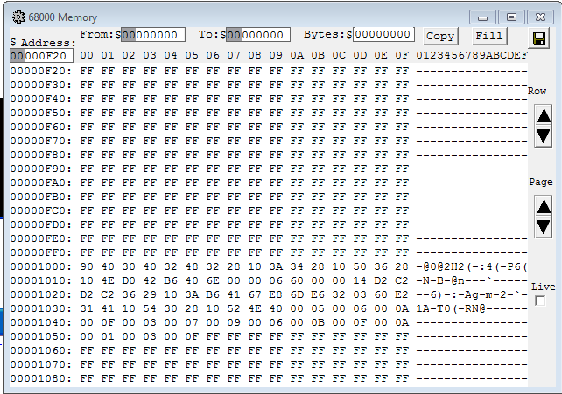

- After hand assembly you can find that the value of L = 1054,1055 where in this code the Org = $1000 so that the largest value 0F stored here

